

**Assessment Report**

on

**“FASHION ITEM CLASSIFICATION”**

submitted as partial fulfillment for the award of

**BACHELOR OF TECHNOLOGY**

**DEGREE**

SESSION 2024-25

in

**CSE(AI)**

By

Group members:

Priyesh Kumar (202401100300

Rishabh Sharma (202401100300200)

Ritesh Bhaskar (202401100300202)

Ram Avtar Chaudhary (202401100300

Satyam Singh (202401100300

Section: C

**Under the supervision of**

“Mayank Lakhotia”

**KIET Group of Institutions, Ghaziabad**

**May, 2025**

**Introduction: Fashion Item Classification**

Have you ever shopped for clothes online? When you search for “T-shirt” or “jeans,” the website quickly shows you the right clothes. But how does it know which item is which? That’s where **fashion item classification** comes in!

Fashion item classification means using a computer to look at pictures of clothes and tell what type of clothing it is. For example, it can look at a picture and say, “This is a shoe,” or “This is a dress.” This is done using a type of computer science called **machine learning** and **artificial intelligence (AI)**.

Instead of a person looking at each picture and labelling it, a smart computer program learns from many examples and does it automatically. This saves a lot of time and helps fashion websites and apps work faster and better.

In this project, we will train a computer model to look at pictures of clothes and recognize what type of item it is.

**Methodology: How We Solved the Problem**

To teach a computer how to recognize clothes, we followed a step-by-step process. Here's how we did it:

**1. Collecting the Data**

We used a dataset called **Fashion MNIST**. This dataset has **images of different clothing items**, like T-shirts, dresses, shoes, and bags.

* Each image is **28x28 pixels** in black and white.
* There are **10 categories** of clothes in the dataset.

**2. Preprocessing the Data**

Before giving the images to the computer, we needed to clean and prepare them.  
We did this by:

* **Normalizing the images** (making pixel values between 0 and 1)
* **Splitting the data** into two parts:
  + **Training data** (used to teach the model)
  + **Testing data** (used to check how well it learned)

**3. Building the Model**

We used a **machine learning model** called a **neural network**.

* It works like a brain, with layers of "neurons" that learn patterns.
* We used tools like **TensorFlow** or **Kera’s** (Python libraries) to build it.

**4. Training the Model**

We gave the model thousands of labelled images and told it what each one was.

* The model looked at the images and tried to learn the differences.
* We trained it over **several rounds (called epochs)** to help it learn better.

**5. Testing the Model**

After training, we gave the model new images it hadn’t seen before.

* The model guessed the clothing type.
* We checked how many answers were correct to measure its **accuracy**.

**6. Improving the Model (Optional)**

If the model didn’t perform well, we could:

* Add more layers
* Change how fast it learns (learning rate)
* Train it for more rounds

**Objectives:**

1. 🎯 **To build a computer program that can recognize and classify fashion items from images.**
2. 📊 **To use the Fashion MNIST dataset for training and testing the model.**
3. 🧠 **To apply machine learning (especially neural networks) to teach the computer how to identify clothes.**
4. 🧪 **To test the model and check how accurately it can predict the type of clothing.**
5. 🔧 **To improve the model's performance by adjusting its settings and training it better.**

CODE:

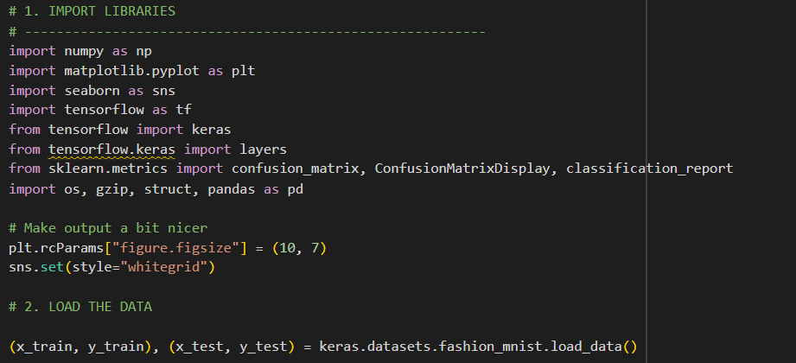

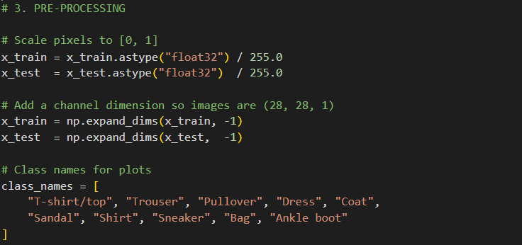

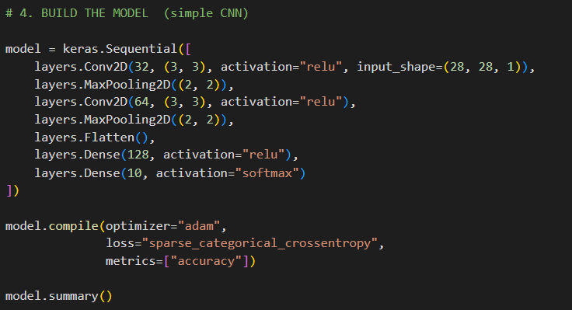

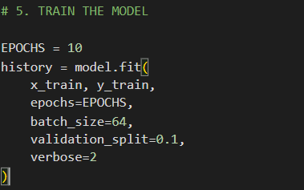

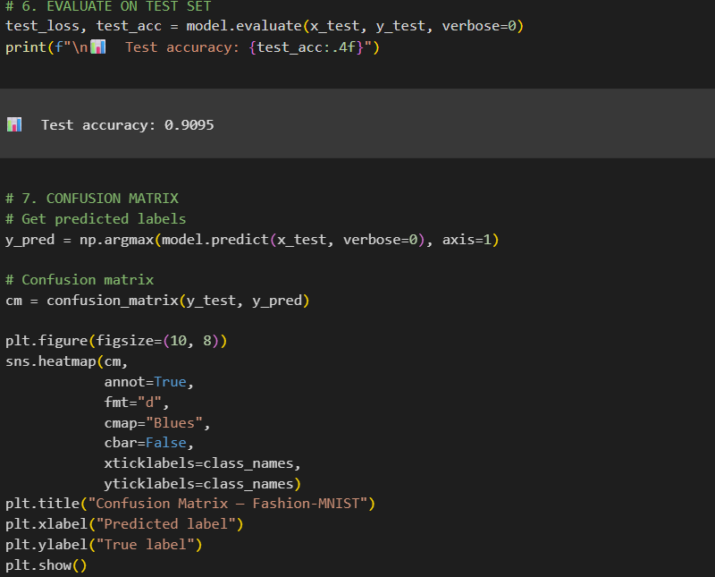

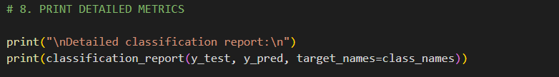

OUTPUT IMAGES:

